|  |  |  |  |  |  |  |
| --- | --- | --- | --- | --- | --- | --- |
| Document ID | | | | | | |
| Document Title | | | Offset Measurement Report Caisson {{ CaissonNumber }} | | | |
| Employer Document Reference | | | {{ DIMCONDocumentReference }} | | | |
| Employer | | | Elia Asset NV/SA | | | |
| Project Name | | | EPCI Energy Island for MOG2 Project | | | |
| Scan QR code to check if this is the latest revision   |  | | --- | |  |   Revision Status | | | | | | |
| Rev. | Date | Description | | Prepared | Checked | Approved |
| 00 | Click or tap to enter a date. | Document creation date | | EHB |  |  |
| 01 |  | First Issue | |  |  |  |
|  |  |  | |  |  |  |

Table of Contents

1. Project Description 5

1.1 Scope of Document 5

1.2 References 5

1.2.1 Internal References 5

1.2.2 Elia References 6

1.3 Abbreviations 6

2. General Information 7

2.1 Overview 7

2.2 Points of Interest 7

2.3 Civil Survey Team 8

3. Equipment and Software 9

3.1 Equipment Used 9

3.2 Software Used 9

4. Survey Methodology 10

4.1 Object Description 10

4.2 Measurement Process 11

4.3 Survey Equipment Reference Points 12

4.3.1 GNSS 12

4.3.2 MRU 14

5. QA/QC 17

5.1 Caisson Movement Validation 17

5.2 Total Station Setup Verification 18

6. Results 20

6.1 Overview 20

6.2 List 20

6.3 Pictures 21

7. Annexes 24

7.1 Leica TS16 - Datasheet 24

7.2 Leica Nova_MS60 - Datasheet 25

7.3 Calibration Certificate Leica MS60 sn895049 26

7.4 Calibration Certificate Leica TS16 sn3262674 27

7.5 Calibration Certificate Leica TS16 sn3203088 28

7.6 Verification Report Leica MS60 sn895049 29

7.7 Verification Report Leica TS16 sn3262674 30

7.8 Verification Report Leica TS16 sn3203088 31

7.9 Prism Reference Locations Yard Denemarkenweg 32

7.10 Tallysman VSP6037L 33

7.11 SBG Navsight & Base Plate 34

Table of Figures

Figure 1: Indicative overview POIs locations in the caisson reference frame 8

Figure 2: Caisson reference frame 10

Figure 3: PS-GNSS antennas Fore and Aft {{ CaissonNumber }}, as installed and used on Caisson {{ CaissonNumber }} 12

Figure 4: Indicative measured point – GNSS antennas used on all Caissons. 12

Figure 5: {{ CaissonNumber }} - Leica MPR122 prism 13

Figure 6: Offset diagram GNSS antennas as used on all Caissons 13

Figure 7: {{ CaissonNumber }} - GNSS antenna selected in GNSS receiver 13

Figure 8: {{ CaissonNumber }} - Installed MRUs . 14

Figure 9: Dimensions and location of the Base Plate, installed on all Caissons 14

Figure 10: {{ CaissonNumber }} - MRU user interface 15

Figure 11: Indicative use of the Base plate ruler, as used on all Caissons 15

Figure 12: indicative MRU cover target marking, Indicative as used on all Caissons 16

Figure 13: MRU offset diagram – as used on all Caissons 16

Figure 14: Exaggerated example of caisson displacement 17

Figure 15: {{ CaissonNumber }} – ST5 Total station setup verification report with prisms 360-8/7/6/2/1 18

Figure 16: {{ CaissonNumber }} – ST6a Total station setup verification report with prisms on 2112-2191-3037-ref2 18

Figure 17 {{ CaissonNumber }} – ST6b Total station setup verification, using PR307-308-309 and {{ CaissonNumber }}.1-{{ CaissonNumber }}.2- {{ CaissonNumber }}.4 19

Figure 18 : {{ CaissonNumber }} – ST6c Total station setup verification, using {{ CaissonNumber }}.1-{{ CaissonNumber }}.2-{{ CaissonNumber }}.3-{{ CaissonNumber }}.4 and {{ CaissonNumber }}.6 19

Figure 19:S3 - Locations of measured points within the caissons reference frame 20

Figure 20: S3 GNSS Antenna Aft -Fore 21

Figure 21: Indicative MRU reference points with ruler for visual purposes, 21

Figure 22 indicative picture of a materialised Reference Nail 22

Figure 23 indicative picture of a materialised Reference Prism 22

Figure 24 Spread of the REF-marks on S3 23

Table of Tables

Table 1: Referencing to internal documents 5

Table 2: Referencing to Elia documents. 6

Table 3: Abbreviations 6

Table 4: {{ CaissonNumber }} - General information 7

Table 5: {{ CaissonNumber }} Equipment used 9

Table 6: Caisson reference frame 10

Table 7: {{ CaissonNumber }} -GNSS antennas 12

Table 8: MRU equipment 14

Table 9: {{ CaissonNumber }} – Caisson’s Measured displacement 17

Table 10: {{ CaissonNumber }} - Coordinate list of all POIs within the caisson reference frame 21

1. Project Description

A detailed Project Description can be found in the General Project Information [1].

* 1. Scope of Document

This report gives a detailed overview of the measured offsets for the points of interest related to caisson {{ CaissonNumber }}, with all offsets within the defined caisson reference frame. The aim of this report is to document the caisson’s fixed, materialised and non-materialised offsets, along with its outer contours. These measurements are integral to the following processes:

* Qinsy Shape Verification: Ensuring the accurate representation of the caisson’s geometry within Qinsy for alignment and positioning validation.
* Qinsy Online Caisson Visualisation: Facilitating real-time monitoring and visualisation of the caisson’s location, orientation and alignment during installation operations.
* Installed Position Report: Providing detailed information on the caisson’s position after it has been placed and filled with water, verifying compliance with design tolerances.
* As Built Position Report: Capturing the final position of the caisson following sand-filling, confirming its alignment and stability against design specifications.

This report ensures that the caisson meets all project requirements and provides a reliable reference for quality assurance and operational planning.

This report does not describe any calibrations/verifications of survey sensors. Reference is made to {{ MCRDocumentReference }}

* 1. References
     1. Internal References

|  |  |  |  |
| --- | --- | --- | --- |
| **Ref.** | **Document Number** | | **Document title** |
|  | MOG2-EDI-ISZ-PMZ-MGP-0011 | | General Project Information |
|  | MOG2-EDSN-PEX-MST-00004 | | PEP-Perimeter Construction |
|  | MOG2-EDI-WPZ-MSV-PRO-0001 | | Geodetic Setup |
|  | MOG2-EDI-ISZ-MSV-PRO-0001 | | General Survey Method Statement |
|  | MOG2-EDI-ISZ-QUA-MGP-0005 | | ITP Marine Survey Activities |
|  | MOG2-EDI-ISI-CIV-RAM-0001 | | Flushing Topographic Caisson Construction Procedure |
|  | {{ MCRDocumentReference }} | | Installation and Calibration Report for Caisson {{ CaissonNumber }} |
|  | | {{ DocumentReference8 }} | Design dimensions for Caisson {{ CaissonNumber }} |
|  | {{ DocumentReference9 }} | | As Built dimensions for Caisson {{ CaissonNumber }} |

Table 1: Referencing to internal documents

* + 1. Elia References

|  |  |  |
| --- | --- | --- |
| **Ref.** | **Document Number** | **Document title** |
|  | MOG2-IMD-SZZIN-00001_v02 | 3.B.6_Survey Requirements |
|  | 3.B.6_Annex B | Survey Data Deliverables |
|  | MOG2-ELI-SZZIN-00002_v01 | 3.B.7 - Survey Technical Requirements |

Table 2: Referencing to Elia documents.

* 1. Abbreviations

|  |  |
| --- | --- |
| Abbreviation | Definition |
| APC | Antenna Phase Centre |
| ARP | Antenna Reference Point |
| c-o | Calculated minus Observed |
| CRS | Coordinate Reference System |
| CSC | Compact Survey Case |
| DIMCON | Dimensional Control |
| GNSS | Global Navigation Satellite System |
| IMU | Inertial Motion Unit |
| MRU | Motion Reference Unit |
| NTRIP | Network Transport of RTCM via Internet Protocol |
| POI | Point Of Interest |
| RTCM | Radio Technical Commission for Maritime Services |
| RTK | Real Time Kinematic |
| ST5 | Station 5 |
| ST6 | Station 6 |
| UHF | Ultra-High Frequency |
| UCS | User Coordinate System |
| QA/QC | Quality Assurance / Quality Control |

Table 3: Abbreviations

1. General Information
   1. Overview

The following tables provides an overview of the key details of the survey conducted for caisson {{ CaissonNumber }}:

|  |  |
| --- | --- |
| Items | Details |
| Survey Date(s) | (ST5), (ST6), (ST6), (ST6) |
| Caisson ID | {{ CaissonNumber }} |
| Location | Station 5 & Station 6, Flushing |
| Purpose | To measure and document the offsets of fixed, materialised, and non-materialised POIs (see §2.2). |
| Personnel | TCO, EZO, AH, BSW, |
| Lighting | Daylight operations |
| Constraints | None |
| CRS | Caisson reference frame |

Table 4: {{ CaissonNumber }} - General information

* 1. Points of Interest

Below a summary of the key POIs surveyed within the caisson reference frame for the dimensional control and offset verification for caisson {{ CaissonNumber }}:

* GNSS Antennas (4): Positions of antenna bases,
* MRUs (2): Locations of MRUs and alignment of baseplate.
* Caisson Corners (Upper and Lower): Fixed; non-materialised corner points defining the caisson's outer contours,
* Initial Reference Points (9): Permanent fixed and materialised reference marks (i.e. survey nails and Prisms).
* Centreline (P1-P2): Non-materialised reference points defining the caisson's centreline.

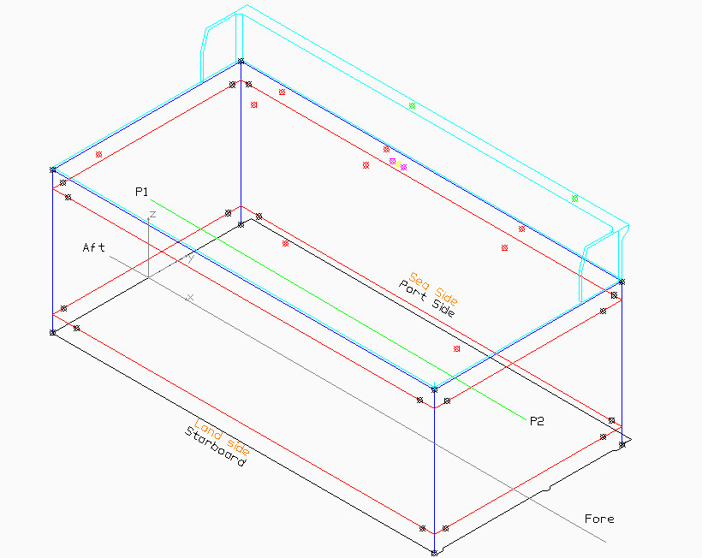

⦻ GNSS Antennas

⦻ MRUs

⦻ MRU baseplate ruler

⦻ Caisson corner points

⦻ Reference marks

Figure 1: Indicative overview POIs locations in the caisson reference frame

* 1. Civil Survey Team

The civil survey team currently exists of 4 members, each responsible for specific roles in the survey process. Dimensional control is carried out at station 5-6, where final alignment and offset measurements are performed. The team is expected to expand in the coming months to meet increasing project demands and enhance operational capacity.

Eric Zondervan (EZO)

Civil Surveyor

Tom Cochez (TCO)

Lead Civil Survey

*Station 1-5*

André Haak (AH)

Civil Surveyor

Bart Sweere (BSW)

Civil Surveyor

*Station 6*

1. Equipment and Software

In this section, an overview is provided of the equipment and software utilised for the survey of caisson {{ CaissonNumber }} offsets. The selected tools and systems ensured precise measurements and efficient data processing, meeting project’s accuracy requirements and technical standards.

* 1. Equipment Used

Surveys relied on two high-precision total stations, both calibrated and verified prior to use (see Annex 7.1 till 7.7 - Details of the equipment are listed below and in their respective annexes:

|  |  |  |  |
| --- | --- | --- | --- |
| Equipment | Type | Sn | Annex |
| Total Station | Leica MS60 | 895049 | 7.2, 7.3, 7.6 |
| Total Station | Leica TS16 | 3262674 | 7.1, 7.4, 7.7 |
| Total Station | Leica TS16 | 3203088 | 7.1, 7.5, 7.8 |

Table 5: {{ CaissonNumber }} Equipment used

* 1. Software Used

The data collected on-site was processed and analysed using the following software:

1. Leica Captivate: The Leica MS60 and TS16 total stations are integrated with Leica’s Captivate software, enabling real-time analysis, calculation, and visualisation of survey data during field operations.
2. AutoCAD Civil 3D: Post-processing of the collected survey data was conducted using Civil 3D 2024, generating dimensional models for the caisson and validating measured offsets against design specs.
3. BricsCAD: To refine the data and produce detailed 2D and 3D CAD models, BricsCAD was used next to Civil 3D. Offset drawings were generated using this software.
4. Survey Methodology
   1. Object Description

The caisson reference frame serves as the basis for all measurements and calculations, ensuring consistency and alignment with project specifications. The X/Y plane of the caisson will be determined at station 1. The Z axis will be perpendicular to this plane. All measurements for {{ CaissonNumber }} were conducted within this user defined caisson reference frame and is configured as follows:

|  |  |  |
| --- | --- | --- |
| Axis | Origine at | Positive Direction |
| X | Aft perpendicular | Towards Fore |
| Y | Centre Line (CL) | Towards Portside |
| Z | Baseline (or keel) (BL) | Upwards |

Table 6: Caisson reference frame

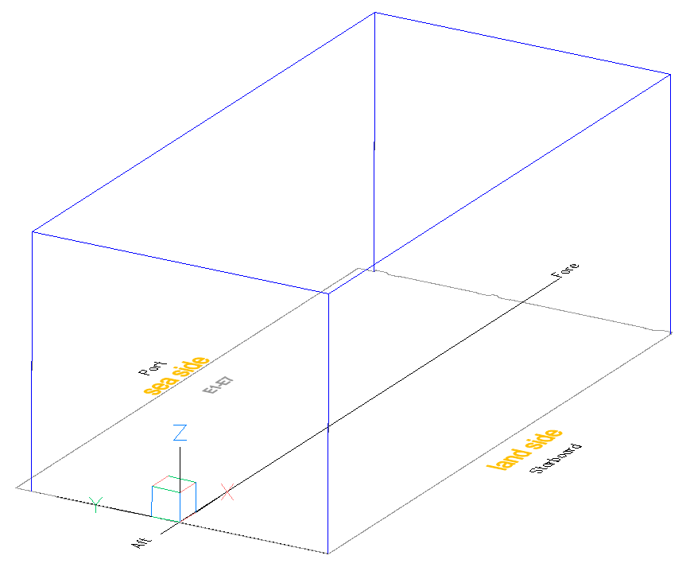

Figure 2: Caisson reference frame

* 1. Measurement Process

The DIMCON measurement process is conducted in two key stages. The first one takes place at station 5 (Denemarkenweg), where the initial measurements are conducted to establish the caisson outer contours. Non-materialised auxiliary points (32) are surveyed, from which the calculation of the vertical ribs and theoretical corner points is derived. These measurements provide a geometric baseline for the caisson.

Following these measurements, the caisson is skidded onto the BOA barge and floated off to station6 (Scaldia), where the roof top slab will be poured, and the survey equipment is installed. The final DIMCON survey will take place to determine the offsets for all fixed survey equipment and reference points.

1. Establishing the Theoretical Caisson Corner Points and Centre Line

* The vertical ribs of the caisson are first defined based on measurements conducted at station 5.
* At least four points are measured on each wall using a total station to determine the caisson’s structural alignment. Measurements are taken at two heights: lower level (Z = 1.666m) and upper level (Z = 19.665m).
* These measured points form two lines within each caisson face. When extended, these lines intersect on the corner of the caisson, each defining a coordinate on the vertical ribs of the caisson.
* The bottom corner of the caisson is determined by the rib intersection at Z = 0, while the upper corner aligns with the design level of the caisson at Z = 22.925 m.
* From the caisson corner points, the theoretical centre line can be determined. The points P1 and P2 (fixed, but non-materialised) will be used as targets to position the caisson on its final location at the PEI.

For a more detailed procedure description on the calculation of the theoretical caisson corner points, please refer to the Flushing Topographic Caisson Construction Procedure[9].

1. DIMCON Survey Equipment

* At station 6, the final survey focuses on precisely measuring and determining the XYZ offsets of the survey equipment within the caisson reference frame using a total station. These measurements include the mount base of 4 GNSS antennas, the cover target of 2 MRUs, 6 survey nails and 3 prisms.
* To ensure accurate alignment of the MRUs relative to the X-axis of the caisson reference frame, a ruler was placed along the baseplate to have an extended line for the baseplate to minimise error.
* Two measurement points were recorded along this extended line (Referred as Baseplate Ruler in
* These points were used to determine the heading (yaw) offset of the MRUs relative to the caisson reference frame.
  1. Survey Equipment Reference Points
     1. GNSS

An overview of the antennas used can be found in Table 7.

|  |  |  |  |  |
| --- | --- | --- | --- | --- |
| Equipment | Make | Model | Sn | Annex |
| GNSS Antenna 1 | Tallysman | VSP6037L | {{ SN_Ant1 }} | 7.10 |
| GNSS Antenna 2 | Tallysman | VSP6037L | {{ SN_Ant2 }} | 7.10 |
| GNSS Antenna 3 | Tallysman | VSP6037L | {{ SN_Ant3 }} | 7.10 |
| GNSS Antenna 4 | Tallysman | VSP6037L | {{ SN_Ant4 }} | 7.10 |

Table 7: {{ CaissonNumber }} -GNSS antennas

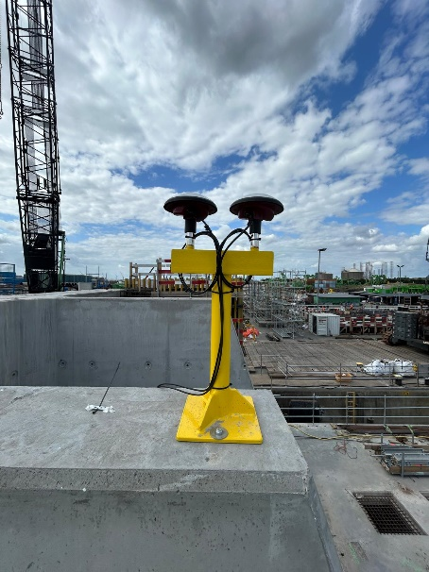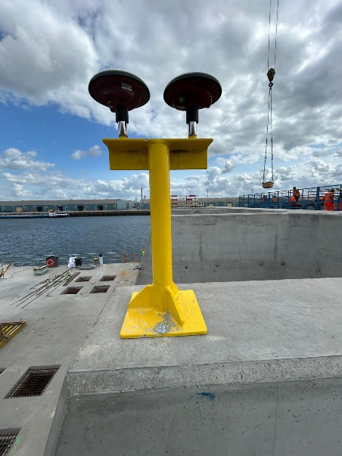 .

GNSS {{ CaissonNumber }} FORE

GNSS {{ CaissonNumber }} AFT

Figure 3: PS-GNSS antennas Fore and Aft {{ CaissonNumber }}, as installed and used on Caisson {{ CaissonNumber }}

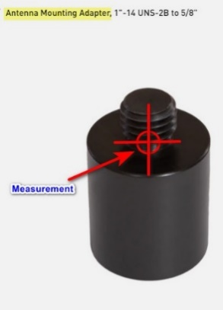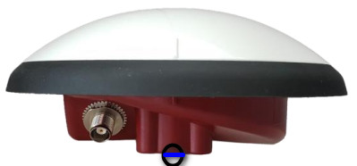

Figure 4: Indicative measured point – GNSS antennas used on all Caissons.

The GNSS reference point was measured using a Leica MPR122 prism, which has a 50 mm height offset from the prism centre to the bottom of the thread which coincides with the antenna reference point.

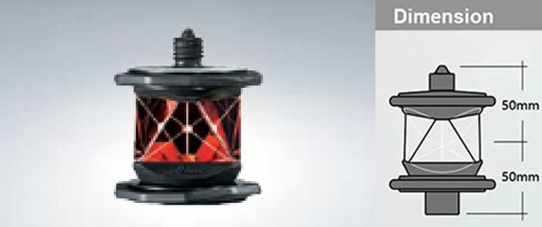

Figure 5: {{ CaissonNumber }} - Leica MPR122 prism

The GNSS receivers can work with both the antenna phase centre (APC) or the antenna reference point (ARP). This is selected inside the unit’s user interface portal as shown in Figure 7.

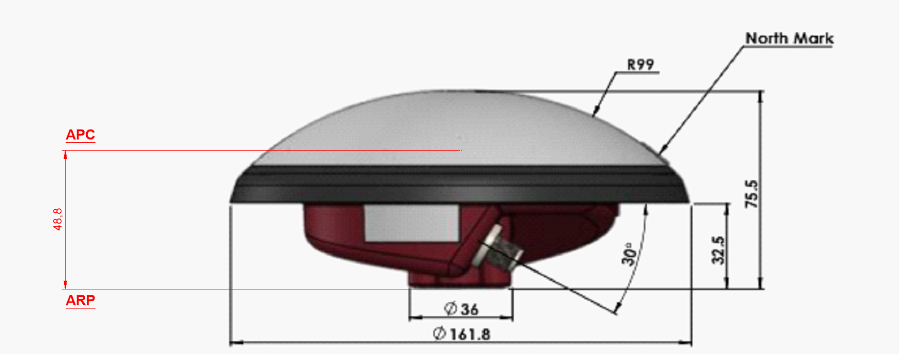

Figure 6: Offset diagram GNSS antennas as used on all Caissons

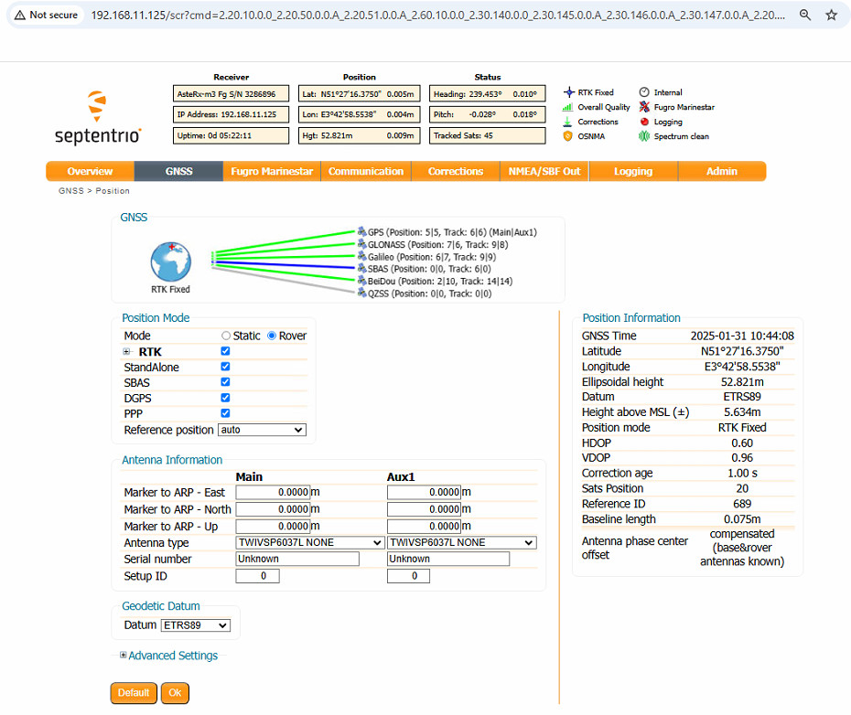

Figure 7: {{ CaissonNumber }} - GNSS antenna selected in GNSS receiver

* + 1. MRU

An overview of the MRUs can be found in table 8.

|  |  |  |  |  |
| --- | --- | --- | --- | --- |
| Equipment | Make | Model | Sn | Annex |
| MRU 1  IP{{ IP_1 }} | SBG | Navsight-S-RU  Ekinox | {{ SN_SBG1 }} | 7.11 |
| MRU 2  IP{{ IP_2 }} | SBG | Navsight-S-RU  Ekinox | {{ SN_SBG2 }} | 7.11 |

Table 8: MRU equipment

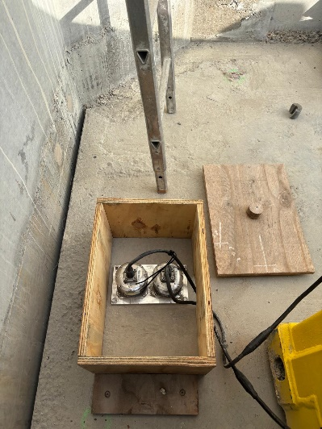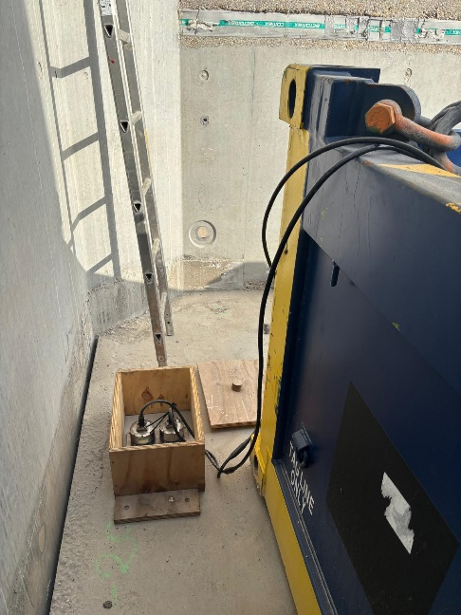

IP {{ IP_1 }}&{{ IP_2 }} - PS

Figure 8: {{ CaissonNumber }} - Installed MRUs .

For best measurement and accuracy, both MRU units are installed on a baseplate, fabricated by MGB TECH, according to the manufacturer’s drawing and specifications. See also Annex 7.11

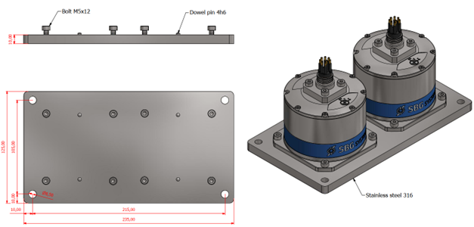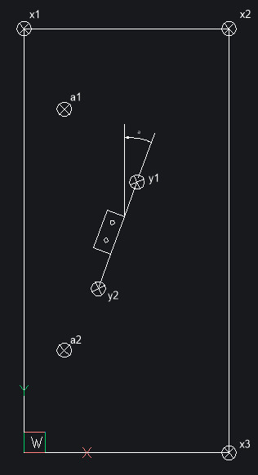

Figure 9: Dimensions and location of the Base Plate, installed on all Caissons

To minimize the crosstalk between Pitch and Roll we need to enter the YAW, α in Figure 9, into the MRU units. The alignment (YAW) of the base plate for the two MRUs was measured by placing a ruler against the base plate and measuring the extents of the ruler, y1 and y2 in Figure 9, to have a longer baseline to determine the orientation of said base plate as shown in Figure 11.

As the physical centre point of the motion reference unit cannot be measured, the cover target on top is used to measure in as shown in Figure 12. The offset from the cover target to the unit’s centre is a standard selectable in the system’s web user interface page as shown in Figure 10 and thus needs no further correction towards the centre of the IMU.

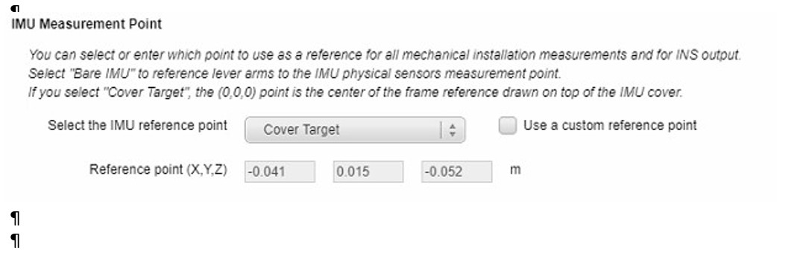

Figure 10: {{ CaissonNumber }} - MRU user interface

The offset differences between the Cover Target (Figure 12) and the IMU reference is shown in .

Figure 13.

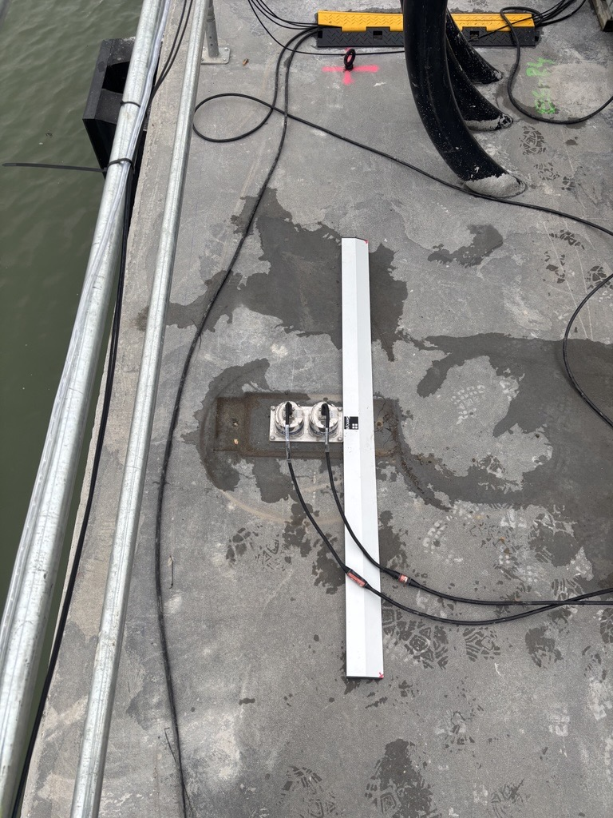

Figure 11: Indicative use of the Base plate ruler, as used on all Caissons

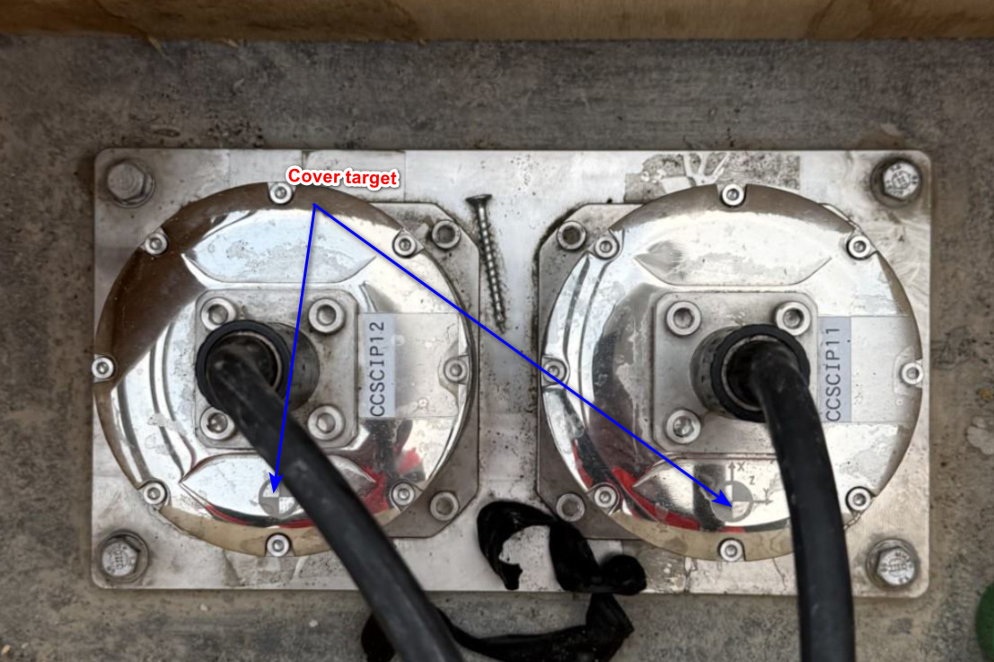

Figure 12: indicative MRU cover target marking, Indicative as used on all Caissons

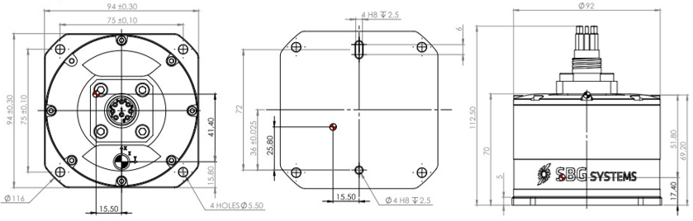

.

Figure 13: MRU offset diagram – as used on all Caissons

1. QA/QC
   1. Caisson Movement Validation

To track potential displacement during caisson movement between stations, a pre-move and post-move survey was conducted at each transition using four survey prisms placed at or near the caisson’s four corners to serve as control points. These prisms remained fixed in position throughout the caisson’s movement. This check ensured that any movement of the caisson between stations did not introduce significant alignment errors or deviations from the intended design.

Figure 14: Exaggerated example of caisson displacement

1. Pre-Move Survey: Before the caisson was repositioned, a total station was used to record the exact X, Y, and Z coordinates of the four prisms in a local CRS. These measurements established the baseline positional reference for comparison after movement.
2. Post-Move Survey: Once the caisson reached the next station, a second survey was conducted to remeasure the prism positions and determine the displacement.
3. Alignment of Design with Measured Position: The design model of the caisson was aligned with the updated measured positions. One corner (e.g. Point 4) was locked onto its corresponding surveyed position. The diagonally opposite corner (e.g. Point 2) was rotated into alignment with its measured position. The remaining two corners (Points 1 and 3) were used as redundancy checks to ensure positional integrity.

|  |  |  |  |  |  |  |  |  |  |  |  |
| --- | --- | --- | --- | --- | --- | --- | --- | --- | --- | --- | --- |
|  | ST1 | → | ST2 | → | ST3 | → | ST4 | → | ST5 | → | ST6 |
| Point 1 | *0* |  | 0.011 |  | 0.004 |  | 0.009 |  | 0.020 |  | 0.007 |
| Point 2 | *0* |  | 0.013 |  | 0.009 |  | ntm |  | 0.008 |  | 0.019 |

Table 9: {{ CaissonNumber }} – Caisson’s Measured displacement

* 1. Total Station Setup Verification

Before executing survey measurements, total station position verification was performed to confirm its accuracy. This check was done before each survey to ensure that the instrument’s positional reference was correctly established relative to known control points. The total station was set up in a stable position with a clear view of at least four reference prisms in its surrounding area. Distances and angles to these four known reference points were measured and a calculation of the residuals was performed to determine any discrepancies.

As from Station 6 the total station was setup on previous measure materialised points on the Caisson reference frame itself and resections being evaluated prior continuing measurement in caissons reference frame.

If the calculated deviation remained within acceptable tolerances (≤ 5mm), the setup was approved, and measurements could proceed.

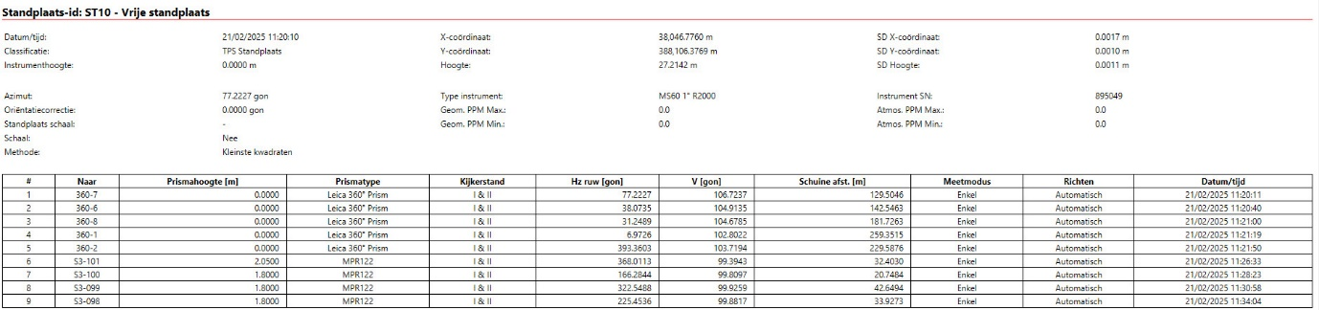

Figure 15: {{ CaissonNumber }} – ST5 Total station setup verification report with prisms 360-8/7/6/2/1

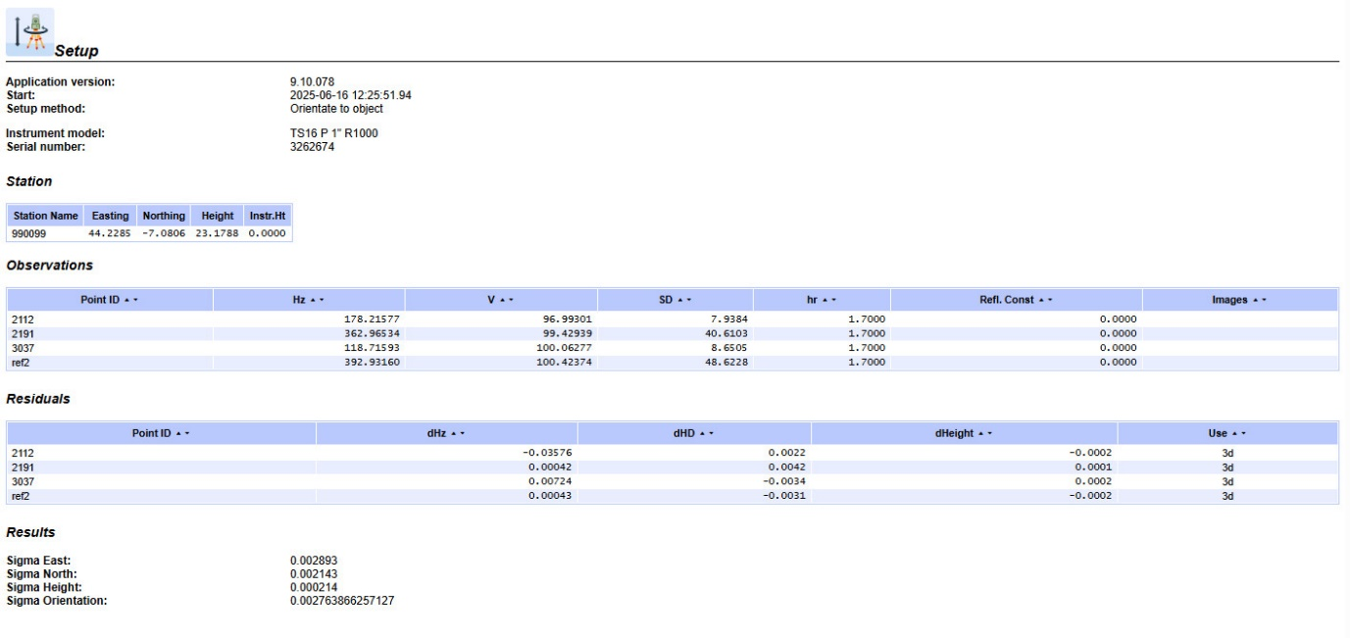

Figure 16: {{ CaissonNumber }} – ST6a Total station setup verification report with prisms on 2112-2191-3037-ref2

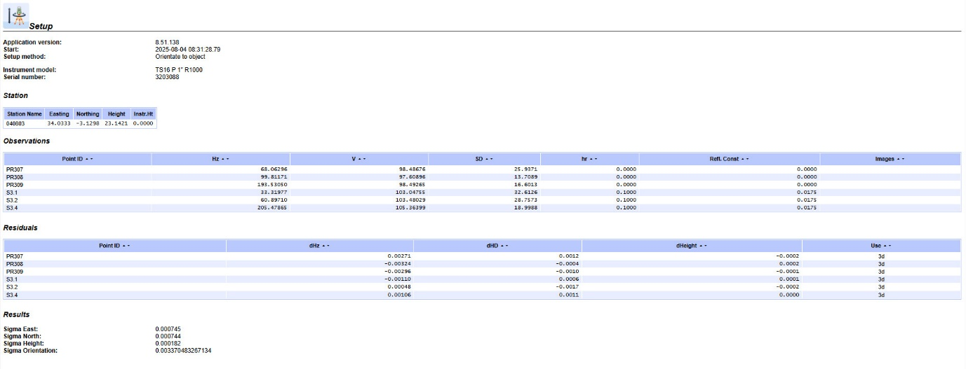

Figure 17 {{ CaissonNumber }} – ST6b Total station setup verification, using PR307-308-309 and {{ CaissonNumber }}.1-{{ CaissonNumber }}.2- {{ CaissonNumber }}.4

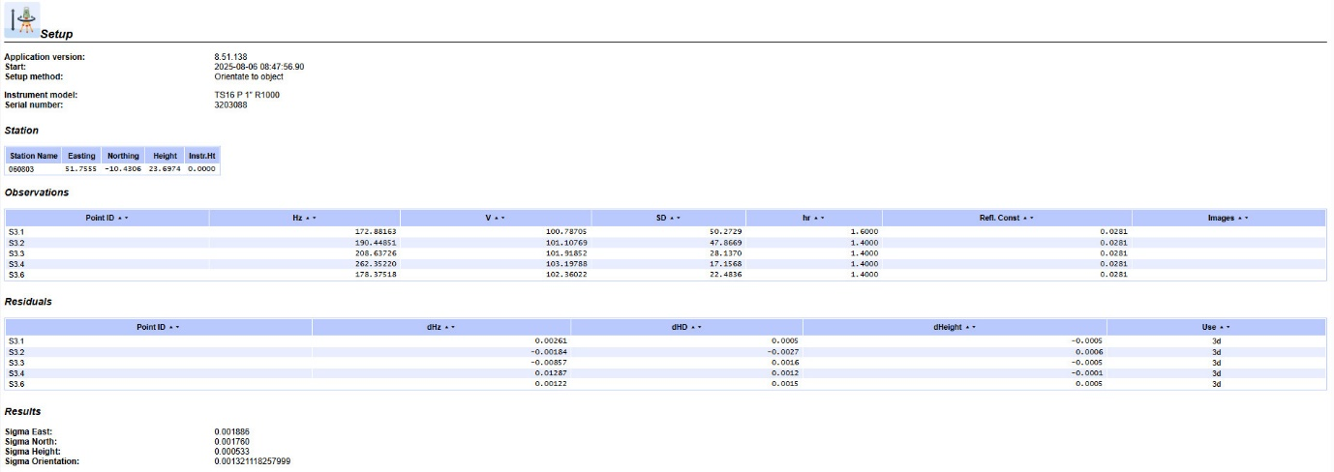

Figure 18 : {{ CaissonNumber }} – ST6c Total station setup verification, using {{ CaissonNumber }}.1-{{ CaissonNumber }}.2-{{ CaissonNumber }}.3-{{ CaissonNumber }}.4 and {{ CaissonNumber }}.6

1. Results
   1. 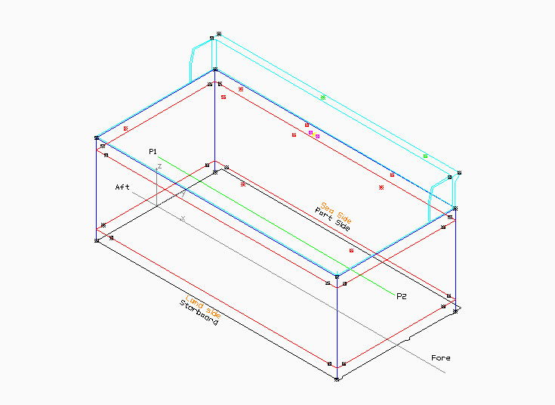Overview

Figure 19:S3 - Locations of measured points within the caissons reference frame



5 & 6

9

17

21

22

26

24

1 & 3

2 & 4

7 & 8

11

12

15

16

18

19

20

23

25

27

10

14

13

* 1. List

|  |  |  |  |  |
| --- | --- | --- | --- | --- |
| ID | Ref. Name | X | Y | Z |
| 1 | GNSS01 A1 antenna mount base | 20.813 | 8.982 | 28.599 |
| 2 | GNSS02 A2 antenna mount base | 46.412 | 8.984 | 28.609 |
| 3 | GNSS03 A3 antenna mount base | 20.813 | 9.185 | 28.598 |
| 4 | GNSS04 A4 antenna mount base | 46.416 | 9.184 | 28.612 |
| 5 | MRU Ekinox 1 Cover target | 49.973 | 13.148 | 21.520 |
| 6 | MRU Ekinox 2 Cover target | 49.971 | 13.258 | 21.520 |
| 7 | PS-Baseplate ruler 1 | 49.270 | 12.977 | 21.429 |
| 8 | PS-Baseplate ruler 2 | 50.759 | 12.999 | 21.440 |
| 9 | Reference Mark 1 | 1.632 | -6.542 | 21.485 |
| 10 | Reference Mark 2 | 6.850 | 6.129 | 21.477 |
| 11 | Reference Mark 3 | 29.175 | 6.343 | 21.460 |
| 12 | Reference Mark 4 | 50.252 | 6.642 | 21.443 |
| 13 | Reference Mark 5 | 54.674 | -6.481 | 21.445 |
| 14 | Reference Mark 6 | 29.854 | -6.768 | 21.468 |
| 15 | Reference Prism 7 | 10.579 | 7.937 | 23.765 |
| 16 | Reference Prism 8 | 25.947 | 7.930 | 23.661 |
| 17 | Reference Prism 9 | 46.402 | 7.938 | 23.536 |
| 18 | Caisson Corner UP FW SB (X2) | 57.001 | -13.977 | 21.450 |
| 19 | Caisson Corner UP FW PS (X1) | 56.984 | 14.033 | 21.450 |
| 20 | Caisson Corner UP AFT SB (X3) | 0.005 | -14.004 | 21.450 |
| 21 | Caisson Corner UP AFT PS (X4) | 0.008 | 14.006 | 21.450 |
| 22 | Caisson Corner LOW FW SB (B2) | 56.997 | -13.998 | 0.000 |
| 23 | Caisson Corner LOW FW PS (B1) | 57.003 | 14.004 | 0.000 |
| 24 | Caisson Corner LOW AFT SB (B3) | -0.004 | -14.003 | 0.000 |
| 25 | Caisson Corner LOW AFT PS (B4) | -0.014 | 13.990 | 0.000 |
| 26 | P1 Start Centreline (AFT) | -0.001 | -0.003 | 10.725 |
| 27 | P2 End Centreline (FORE) | 56.996 | 0.016 | 10.725 |
|  |  |  |  |  |

Table 10: {{ CaissonNumber }} - Coordinate list of all POIs within the caisson reference frame

* 1. Pictures

**GNSS antennas**

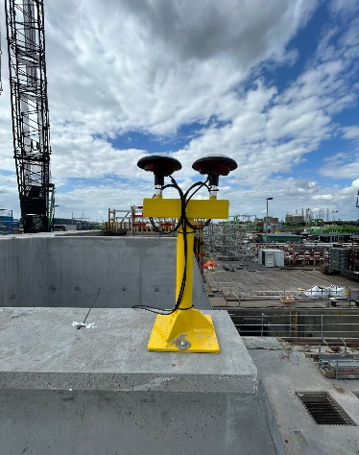

{{ CaissonNumber }} PS Fore

{{ CaissonNumber }}PS Aft

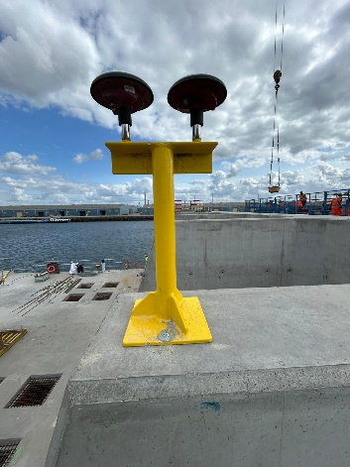

Figure 20: {{ CaissonNumber }} GNSS Antenna Aft -Fore

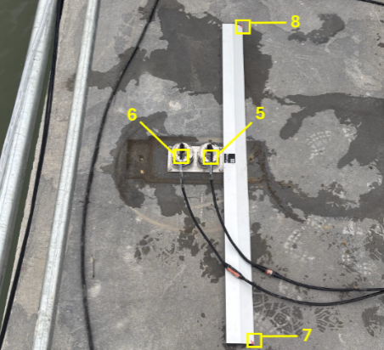

Figure 21: Indicative MRU reference points with ruler for visual purposes,

as installed and used on all Caissons.

**Reference Marks**

Caissons {{ CaissonNumber }} has 6 materialised Reference Nails and 3 Reference Prisms in place- to serve as reference for calibrations verifications and settlement monitoring.

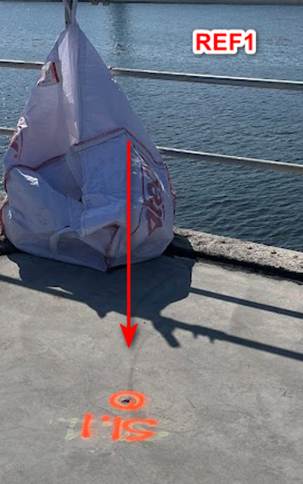

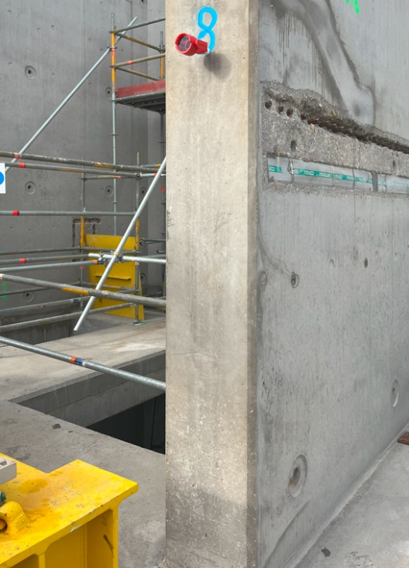

**REF8**

Figure 22 indicative picture of a materialised Reference Nail

Figure 23 indicative picture of a materialised Reference Prism

**Spread on {{ CaissonNumber }}:**

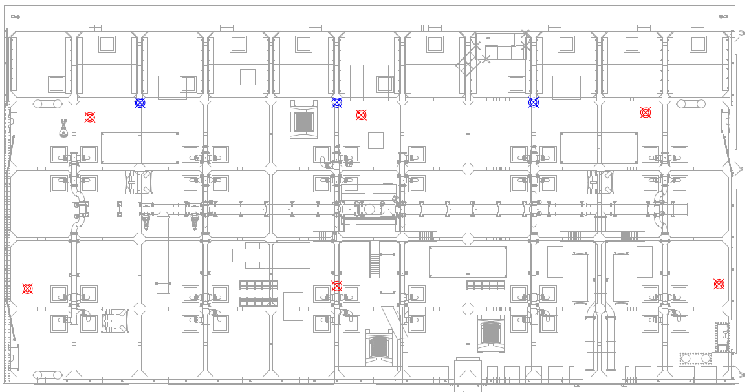

**Aft**

**Fore**

**RM01**

**RM02**

**RM03**

**RM04**

**RM05**

**RM06**

**RM07**

**RM08**

**RM09**

Figure 24 Spread of the REF-marks on {{ CaissonNumber }}

1. Annexes
   1. Leica TS16 - Datasheet
   2. Leica Nova_MS60 - Datasheet
   3. Calibration Certificate Leica MS60 sn895049
   4. Calibration Certificate Leica TS16 sn3262674
   5. Calibration Certificate Leica TS16 sn3203088
   6. Verification Report Leica MS60 sn895049
   7. Verification Report Leica TS16 sn3262674
   8. Verification Report Leica TS16 sn3203088
   9. Prism Reference Locations Yard Denemarkenweg
   10. Tallysman VSP6037L
   11. SBG Navsight & Base Plate